# 

Faculty of Computing

Semester 1 / 20232023

SECP1513 Technology & Information System

Section 02

Design Thinking Report

Lecturer: Dr. Aryati binti Bakri

Group 3

Topic: Apps and Application

Group Members:

| Cheryl Cheong Kah Voon | A23CS0060 |
| --- | --- |
| Evelyn Goh Yuan Qi | A23CS0222 |
| Joanne Ching Yin Xuan | A23CS0227 |
| Lam Yoke Yu | A23CS0233 |
| Lim Yu Han | A23CS0241 |

# 

# **Table of Content**

**Introduction 2**

Significance and Impact 2

Solution Overview 2

Objective and Overview of the Project 3

**Work Progress & Evidence 3**

**Work Distribution 5**

**Problems and Solutions 6**

**Design Thinking Phase 7**

Empathy: Interview 7

Define: Core concern of our users 7

Ideate: Brainstorm 8

Prototype 9

Testing 11

**Reflection 12**

**Reference 17**

# Introduction

How many times have you found yourself scrolling through your phone, searching for that one membership app you use once in a blue moon? Or do you have many membership cards that are occupying spaces of your wallet?

As consumers, we often encounter the inconvenience of having to download numerous applications for membership purposes, many of which we only use occasionally. Our team members face this issue as well. Furthermore, businesses struggle to effectively promote their membership applications.

### Significance and Impact

Membership programs offered by businesses are designed to build stronger relationships with their customers by offering exclusive benefits, discounts and rewards, which in turn foster customer loyalty and retention. Additionally, some programs require membership fees, which can provide a steady revenue stream for business, which can be used to fund operations, expand services and invest in research and development.

However, the proliferating membership applications can lead to a cluttered user experience and crowded app stores. Our inspiration for addressing this issue comes from the TnG eWallet app, which offers mini programs integrated within the app. However, many users are unaware of this feature. Besides that, TnG does not offer advertising solutions for the brands within the app, leading to missed opportunities for both users and businesses.

### Solution Overview

To address the problem, we propose “EzGo”, designed to consolidate all these membership applications and cards into a user-friendly platform. This solution prioritises convenience for consumers, as they can access all their memberships in a single app. EzGo will provide one time registration functionality, eliminating the need for our users to register repeatedly when signing up for new memberships. Besides, users can easily view their accumulated points for each membership, enhancing the overall user experience. Additionally, collaborating businesses and companies can efficiently promote their membership systems and special offers through our application.

### Objective and Overview of the Project

The objective of this project is to understand the needs of our potential users and create a prototype to illustrate how EzGo works. Our approach includes interviewing lecturers and people in the field of software development. Next, we will use Canva to design the interface and PowerPoint to show the relation between pages. Lastly, we will test our prototype with our potential users and receive their feedback to improve our solution.

# Work Progress & Evidence

| Gantt Chart |
| --- |
| Interview |
| 3rd Meeting (8/11 2023): Ideate Phase |
| 4th Meeting (21/11/2023): Finalisation of Report |
| Testing |
| 5th Meeting (22/11/2023): Prototype discussion (create hardcopy prototype) and video finalisation |

Video Link: <https://youtu.be/aC9fndUbcFg?feature=shared>

# Work Distribution

| **Content Title** | **Description** | **Member** |
| --- | --- | --- |
| Introduction | Brief overview of our problem, solution and project | Lam Yoke Yu |
| Progress Tracking | Keep track of work progress using a Gantt chart and journal | Lam Yoke Yu |
| Problem and Solution | Detailed description of the problem and potential solutions | Cheryl Cheong Kah Voon |
| Interview | Interview potential users or industry professionals to understand user needs and obtain suggestions | Evelyn Goh Yuan Qi |
| Conclude insights from the interview | Understand the core concerns of our user | Cheryl Cheong Kah Voon |
| Ideate | Brainstorm and discuss the general functionality of EzGo | All Members |
| Prototype | Create a prototype to illustrate the user interface of our app | Joanne Ching Yin Xuan & Lim Yu Han |
| Testing | Test our prototype and seek for potential improvements that can be done in the future | Lam Yoke Yu |
| Reflection | Reflect on our goals, impact of the project and our future plans and actions | All Members |
| Video Editing |  | Lim Yu Han, Cheryl Cheong Kah Voon & Lam Yoke Yu |

# Problems and Solutions

Users may encounter some issues while using their application. Therefore, our team has discussed the problem that we found and tried to fix it by proposing an app named EzGo. We found that users may face the following issues for membership purposes and our app may provide the following solution.

| **Problem** | **Solution** |
| --- | --- |
| The users need to download numerous apps for membership purposes. | EzGo will provide an interface that consists of various types of membership from different merchants. Users can access their membership through our app easily. |
| Users are concerned that their personal information, transaction history, and other sensitive data may get hacked within these applications. | We apply secure login mechanisms such as biometric recognition and data encryption in our app EzGo. Users can also control their data themselves whether they want to delete it or not. Our app also cooperates with Google API to protect our user’s data. |
| Users often waste time looking for their membership app for point collection when they pay the bill. | Our app provides a simple interface based on different types of membership apps. This can make it easier for users to find the membership app they need. |
| TnG eWallet app does not provide advertising solutions for the merchants within the app, resulting in missed opportunities for both users and businesses. | Our app will collaborate with businesses and companies so that they can effectively promote their membership systems and special offers through our application. |

# 

# Design Thinking Phase

### Empathy: Interview

We interviewed Dr. Nur Elliyah, lecturer from the Faculty of Computing and Mr Hakimi from UTM Digital to understand their needs.

We asked if they have experienced the problem we proposed, the inconvenience of having to download multiple applications for membership purposes, their feelings when they encounter the problem and suggestions to address the issue. Besides, we introduce “EzGo” to our interviewees and seek suggestions and functionalities that they would like to see in our application.

### Define: Core concern of our users

After our interview session, we found that there was another problem besides downloading numerous applications for membership purposes. Users are concerned about the security of their data. When users apply for this abundance of membership apps, they have reasonable worries regarding the safety of their personal and sensitive data. Users are concerned that their personal information, transaction history, and other sensitive data may get hacked within these applications in an era typified by a rising number of data breaches and privacy problems. Users' trust in the security measures used by these applications weakens, which could discourage them from joining rewards and memberships.

To solve this problem, we apply secure login mechanisms such as biometric recognition and data encryption in our app EzGo. We carry out security checks every three months to protect their data. In addition, we also follow the data protection guidelines set by the government to be transparent about data usage procedures and allow users to control their data settings and remove their data if they so choose.

### 

### Ideate: Brainstorm

We discovered that there are 3 prevalent modes of membership offered among merchants and explored some potential methods to incorporate them into EzGo.

| **Types** | **Overview** | **EzGo** |
| --- | --- | --- |
| Traditional method | Membership cards with barcodes were issued, requiring consumers to present these cards during transactions to accrue points. | Consumers transition to EzGo by adding their existing membership card to our application. Consumers can present the barcode generated by our app upon checkout. |
| Application method | An application containing their membership information is utilised. A QR code or barcode is generated for cashier verification. | Consumers just need to register as a member in our app and present the barcode generated by our app upon checkout. |
| Application with other features | An application that goes beyond basic membership, offering online booking and ordering. | The application will appear as a mini program in EzGo. Consumers do not need to download numerous applications on their phone. |

For merchants with existing loyalty programmes, we will collaborate with them to integrate their systems into our application for a unified consumer experience.

We are also aiming to engage with merchants that are planning to launch loyalty programs, providing them with a streamlined membership system within EzGo.

### 

### Prototype

General Flow Chart

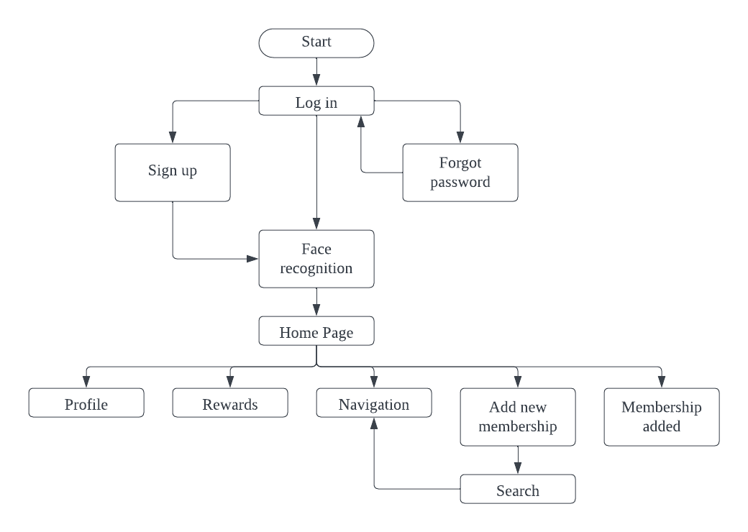

| Login In / Sign Up Pages | |
| --- | --- |
| Home Page | Profile Page |
| Rewards Page | Navigation Page |
| Add new membership | Membership Added |
| Sample membership pages | |

### Testing

We invited our peers to test the prototype. Based on their feedback, they think that the application is user-friendly and can solve the problem that we proposed. However, one individual raised a concern regarding the application's memory consumption which needs to be addressed during the app development phase. We acknowledge that our prototype still contains flaws and requires further improvement.

# Reflection

1. What is your goal/dream with regard to your course/program?
2. How does this design thinking impact on your goal/dream with regard to your program?
3. What is the action/improvement/plan necessary for you to improve your potential in the industry?

| Group members | Reflection |
| --- | --- |
| Cheryl Cheong Kah Voon | 1. My goal with regard to the course Technology & Information Systems is to learn a lot of new things that I have never seen or touched before, such as computer hardware, software operating systems, and more. In this course, I also improved my soft skills via my project, assignment, and industry tour and talk. Then, in my future career, I will be able to apply all of the skills and knowledge I have gained from this course. Aside from that, I aim to become a specialist data engineer who can contribute to the company for which I work.  2. Design thinking can really impact my goals. This is because the emphasis phase in design thinking allows us to clearly understand and define users’ problems, and develop new prototypes and test solutions for them. In addition, it applies teamwork so that problems can be solved quickly and the quality of solutions can be improved.  3. The improvement necessary for me to improve my potential in the industry is to improve my programming skills in SQL, C++, JAVA and more through the short-term course in Coursera and Linkedin. This is because these hard skills are necessary to guarantee my success in the future. Besides, soft skills are necessary to succeed in the future. This is because many technology projects are collaborated among many teams. Collaborating smoothly with others provides a good working atmosphere to produce higher-quality products. So, I will find more opportunities to participate in group projects so that I can improve my soft skills. |
| Evelyn Goh Yuan Qi | 1. My goal with regard to the course Technology and Information System is that I can understand the fundamental concepts in technology and information systems such as hardware, software, networks and databases. Besides, I aim to enhance my problem-solving and critical thinking skills by applying theoretical knowledge to real life situations. For example, I can learn how to analyse problems and design effective solutions using technology. In addition, I seek to develop my teamwork and communication skills through this course as these skills are crucial in completing projects and assignments. 2. In my opinion, this design thinking has significantly enhanced my goals with regard to my program. It is because design thinking requires a holistic understanding of problems, not only obtaining technical aspects but also gaining insights into the human aspects. Moreover, design thinking emphasises the understanding of the needs and experiences of end users, like defining problem statements, ideating, prototyping and testing solutions. It encourages me to analyse problems from different perspectives and develop user-friendly and effective solutions. Furthermore, design thinking fosters teamwork as I collaborated with my group members to complete the project and effective communication is important in design thinking to convey ideas and gather feedback from each other. 3. The improvement that is necessary for me to improve my potential in the industry is to always stay updated with the latest trends and technologies in my field so that I can predict changes and take proactive steps to adapt to these changes. For example, I can attend workshops or seminars and take additional courses to enhance my knowledge and skills. Hence, staying up-to-date with industry trends and technologies is crucial for success in today’s fast-paced world. Besides, I should improve my soft skills including teamwork, communication and work ethic in order to enhance my potential in the industry. It is because soft skills are important for effective collaboration and career advancement. Not only that, good soft skills also can help to increase the work’s efficiency and effectiveness. |
| Joanne Ching Yin Xuan | 1. My goal is to achieve academic excellence in Technology and Information System course by acquiring a comprehensive comprehension of the topic and polishing my practical abilities. My ultimate goal is to apply this expertise to push forward the technology industry, regardless of whether through creative problem-solving, innovative research, or productive system administration. 2. Design thinking has significantly boosted my goals by improving my ability to develop user-centred solutions via innovative problem-solving, design thinking greatly enhances my goals. Utilising this method guarantees that my product development is focused on user demands by giving practical solutions to real-world issues first priority. Design thinking facilitates the introduction of unique features that are in line with the program's emphasis on innovation in app production. In technology and information systems, for example, the creation of the user-friendly and feature-rich app EzGo, which merges all memberships, is an example of how design thinking encourages creative problem-solving and user-centred concepts. 3. The action and improvement for me to improve my potential in industry is to expand my networking by engaging in online forums, attend seminars, and actively interact with industry leaders to expand and build my professional network. Through this I can increase the chance to collaborate with others, and be exposed to a variety of viewpoints inside the field. Besides, I will always seek hands-on experience to continue my learning process. For example, involve myself in real-world industry projects or pursuing additional certification to increase my ability. |
| Lam Yoke Yu | 1. My goal in this course is to learn and understand the fundamentals of computer and computing as it serves as a foundation for our future in the field. I would like to achieve academic excellence and apply what I have learned in the course to my future endeavours. 2. Design thinking is paramount, as it involves problem solving, empathy and innovation, which are vital in the computing industry. We would be constantly solving problems that require creativity and innovation. At the same time, we would need to understand the needs of our end-users when deploying a solution so that the system we produce can cater the needs of our users. It makes me determined to make good systems in the future that can facilitate people. 3. To improve my potential in the industry, I need to hone my leadership and teamwork skills. Throughout the project, I identified some of my weaknesses that require improvement. Despite being a leader in the group, I acknowledge that I could have done a better job in ensuring all members share the common opinion or direction. This consequently caused some minor conflict and misunderstanding in further phases. I understand that setting a good foundation in the starting point is crucial. I realise the need to clearly outline tasks to ensure that nothing is missed out and prevent congestion when the deadline is around the corner. I would keep this in mind and do a better job in the future. Besides, the core problem for the above issue is the communication skills. As the problem can happen due to ineffective communication. Despite challenges, the project was completed successfully. To enhance my communication and leadership skills, I will seek feedback from my teammates and peers. |
| Lim Yu Han | 1. My goal with regard to the course Technology and Information System is to learn about the various aspects of IT like hardware, software, network and some basic skills, so that I can apply these knowledge during practical works in the labs. Other than this, I will develop soft skills like communication and strong problem-solving skills from the classes. Furthermore, I have the chance to gain real work experience because this course also conducts industry talks and visits for students. We can get knowledge from the industry and further build a network with professionals. 2. Design thinking impacts my goal by influencing my problem-solving skill which is the way I approach a problem from multiple perspectives and develop complete solutions. Firstly, design thinking emphasises innovation and creative thinking. For example, we have done a survey and found that there is a problem where people have to download multiple membership applications to seek for discounts or vouchers, then we decided to propose “EzGo” to solve this problem as that takes up storage and is very troublesome. Besides, design thinking also encourages prototyping and testing to refine solutions. So, we have created a prototype and gathered feedback through user testing. 3. To improve my potential in the computer science industry, continuous learning is very important as the technology keeps changing and updating every day. I should actively participate in workshops, courses or competitions relevant to computer science organised by the school. Additionally, I should build a strong portfolio in LinkedIn and GitHub in order to get a job with reasonable wage after my graduation starting from now. To illustrate, I can work on personal or grouping coding projects and then post on these platforms to showcase my technical skills. |

# 

# Reference

P. Chen and R. Huang, "Design Thinking in App Inventor Game Design and Development: A Case Study," 2017 IEEE 17th International Conference on Advanced Learning Technologies (ICALT), Timisoara, Romania, 2017, pp. 139-141, doi: 10.1109/ICALT.2017.161.

Whitney, L. (2017, July 9). How to replace your loyalty cards with an app. *PCMAG*. <https://www.pcmag.com/news/how-to-replace-your-loyalty-cards-with-an-app>

Youjae Yi and Hoseong Jeon (2003). *Effects of loyalty programs on value perception, program loyalty, and brand loyalty. , 31(3), 229–240.* doi:10.1177/0092070303031003002